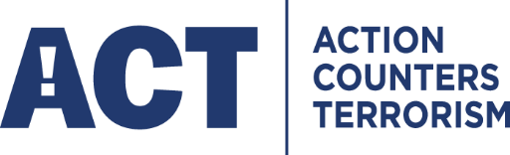

Communities defeat terrorism – and the football fraternity is no exception.

Officers have been taking the Action Counters Terrorism – ACT - campaign to clubs across the country, encouraging them to spread the message to their supporters.

The activity is part of a wider drive to get the sports industry involved in raising awareness of terrorism and suspicious behaviour among visitors to venues and events.

Claire Worley from the West Midlands Counter Terrorism Unit, a CT Security Advisor~~s~~ and keen football fan, told delegates at the national conference of the Football Safety Officers Association (FSOA) that they could make a significant contribution to helping keep local communities safe.

Delegates representing Premier League, EFL and National League clubs were given an overview of the current threat picture and urged to take the steps needed to respond quickly should the threat level be raised to Critical.

The UK threat level from international terrorism is currently at Severe but was twice increased to Critical following attacks at the Manchester Arena and in the London Bridge area last year. This meant enhanced security measures being implemented at public events attracting large crowds.

"The conference was a good opportunity to give the people who are directly responsible for spectator safety an overview of the work we are doing in this sector," says Claire.

"It's also a chance to explain what advice and assistance is available to them from the regional counter terrorism policing units.”

The newly elected FSOA chairman, West Bromwich Albion's Director of Operations Mark Miles, welcomed Claire’s contribution to the Stratford-Upon-Avon conference, adding: "There are lots of options open to clubs to improve safety and security for spectators. Having advice from officers like Claire helps us better understand the type of threats we are facing. This means we can make more informed decisions about the changes we put in place to help keep spectators  and staff safe."

Counter Terrorism Security Advisors are located throughout the UK and can be contacted through local forces.

Below New FSOA Chair Mark Miles discusses the above with Claire Worley

