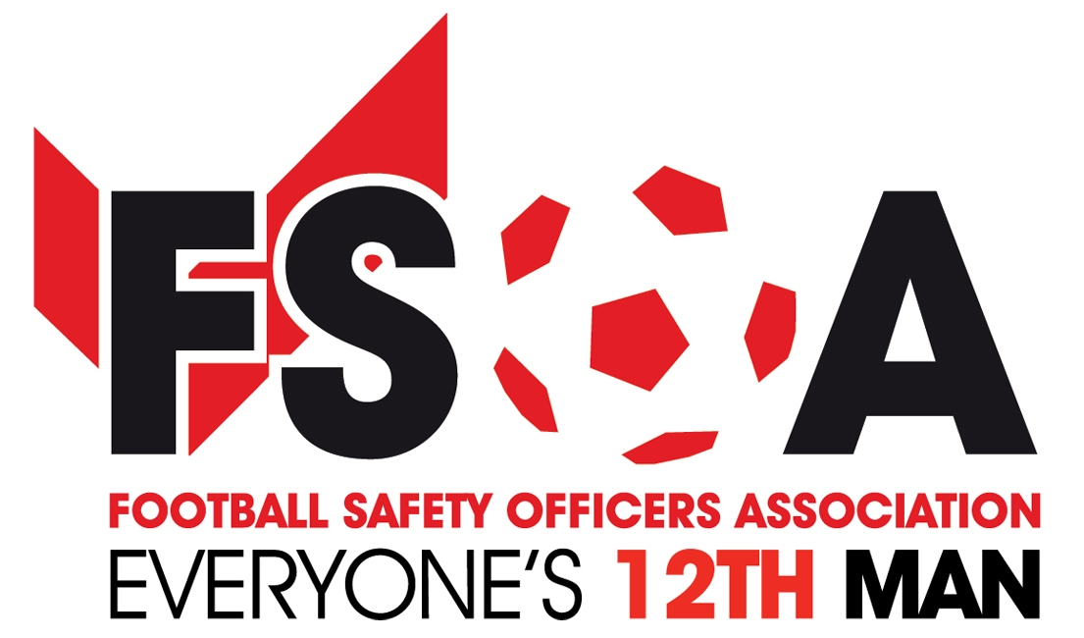
Anniversary Boat trip celebration & curry quiz evening

Tuesday 3rd October 2017
AGENDA
15:00 | Hotel reception/registration for rooms
16:45 | Meet for celebration boat trip on decking area weather permitting  or G’s bar if raining. (pay bar)
17.30 | Celebration Boat trip on the River Avon with complimentary drinks
18:30 | Meet in G’s Private pay bar for Dave’s curry quiz night
Wednesday 4th Agenda
Autumn conference/exhibition
09:00 | Registration and Exhibition ~ Please visit and engage with the exhibitors and sponsors who are supporting the association.
10:00 | Conference ~ Introduction to the day from John Newsham
10:10 | Chairman’s Welcome ~ Sharon Cicco
10:25 | Finance Report ~ Peter Houghton
10:35 | Mark Harding ~ Showsec
10:40 | Steve Hodges ~ Dallmeier
10.50 | The FSOA ~ This is your Life 25 years on
11:15 | Discussion for the future of the association.  ~ Mark Miles/Sharon Cicco
11:40 | Morning break for refreshments and Exhibition visit
12:00 | Claire Worley CTU Threat of Terrorism up-date
12:30 | SKY ~ Sarah Singleton ~ Guardrail heights for camera platforms at sports grounds
13:00 | Lunch and Exhibition, please visit our exhibitors.
14:00 | Aoife Hunt ~ Analysing crowd flow: can we plan for the worst case? company Movement Strategies
14:30 | Let’s Talk stewards training ~ John Newsham
15:00 | Refreshments and Exhibition
15:30 | Open Discussion Questions from the floor to the panel. Chaired by Mark Miles #
16:30 | Conference round-up and summary by Sharon Cicco with introduction to the evenings proceedings.
19:00 for 19:30 | Aperitifs in the bar prior to the evening dinner, followed by an evening with Kevin Keegan & hosted by Andy Ashworth.
# A chance to ask the panel questions on various topics or issues you may have. Panel comprises of
Sharon Cicco, (FSOA Chair)
Alan Wallace (Showsec FSOA’s main sponsor)
Robert Eastwood (Football League)
Claire Worley (CTU),
Steve Hodges (Dallmeier Associate sponsors)
Karen-Eyre-White (SGSA)
Mark Salt I Q Verify / J Newsham (FSOA) (Training Issues)
Aoife Hunt (Crowd Dynamics)
Mark Searle (Footanstey) (Legal Issues)
Sponsors of the Autumn Conference /Exhibition & Evening Dinner
Associate sponsors & sponsors of the 25th anniversary boat trip

