

*Are your Match-day contractors “Match-fit” for the 2017/2018 season?*

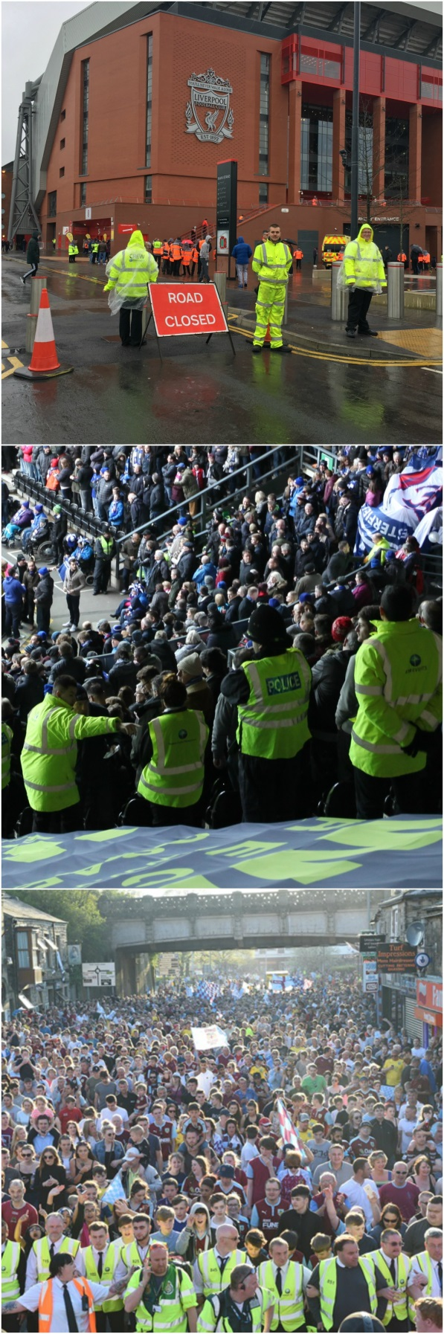

Dear

I do hope you’re well. You may have heard of our company, StadiumTM, as we’re heavily involved with the FSOA. **We specialise in supporting stadium safety officers and operations managers** like you, in delivering a safe match-day operation.

Because of our understanding of the industry, we suspect you may have encountered one or more of the following issues these past years:

* Contractors are **failing to deliver sufficient steward or SIA Licensed numbers consistently**, as per your statutory requirements.
* You feel an **over-dependency on one contractor** to deliver your operation, which has exposed you, at times, to near intolerable risk.
* You have nothing against the **NVQ Level 2 Spectator Safety qualification advised by the SGSA**, it is just the small matter of funding and delivery. Typically, your contractors cannot commit to this. Except for a watered down alternate version that ticks the box but does not promote the quality you are looking for.
* Recent terror attacks have made you wary of whether your **contractor’s right to work and vetting checks of staff are resilient enough**. Or, in particular, of the sub-contractors that they may use.
* These attacks may have also made you wary about the temporary traffic management measures on the road network supplying your stadium. You are concerned **your existing measures may not sufficiently** **prevent a HGV attack** on crowds of spectators around your stadium in the 30-minute window before or after kick-off.

If these issues are chiming with you, then we would like to offer you a free benchmarking exercise to see how we can help. Where we come and meet you, listen to your issues and provide you with our proposed costed solutions that you can compare against your current supplier – **this is all free of charge and without obligation**, so you have nothing to lose in going ahead but will gain key information.

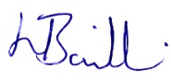E-mail me on [l.baillie@stadiumtm.co.uk](mailto:l.baillie@stadiumtm.co.uk) or feel free to call me on 07808 608605 / 02476 158139. Thank you for taking the time to read this and we look forward to meeting with you well ahead of the 2017/2018 season.

**Ms Lorraine Baillie,**

**Operations Director**



*“We provide the only ultimate ‘end-to-end’, combined services solution tailored to Stadia in the market today.”*

**Our Training**  **Our Operations**

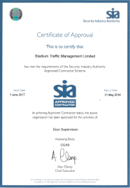

**We undertake field based training to reinforce steward’s theoretical understanding.**

**We’re an approved SIA contractor supplying Licensed Security Operatives undertaking search/response duties.**

**Trained Banksmen to safely manage your coach/bus parking operations**

**We are an Approved HABC Centre.**

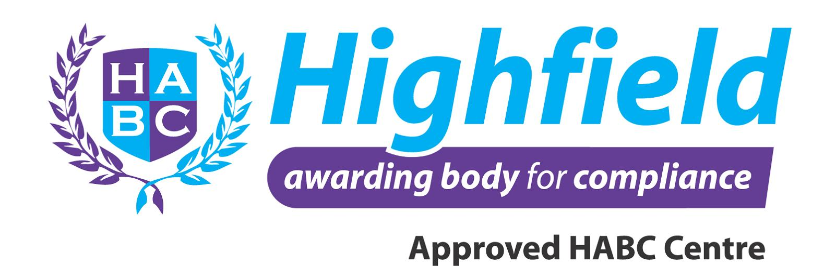

**Teaching and learning is in classroom “face-to-face” environments.**

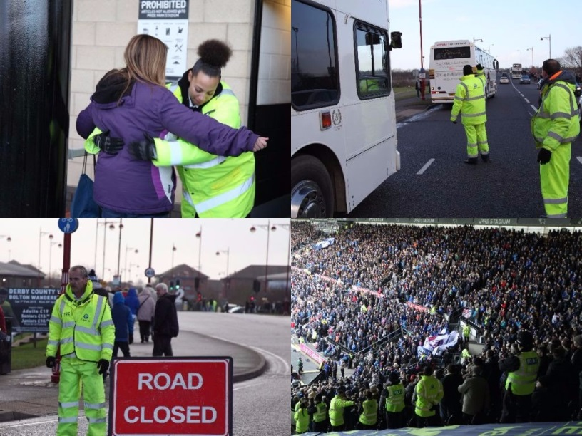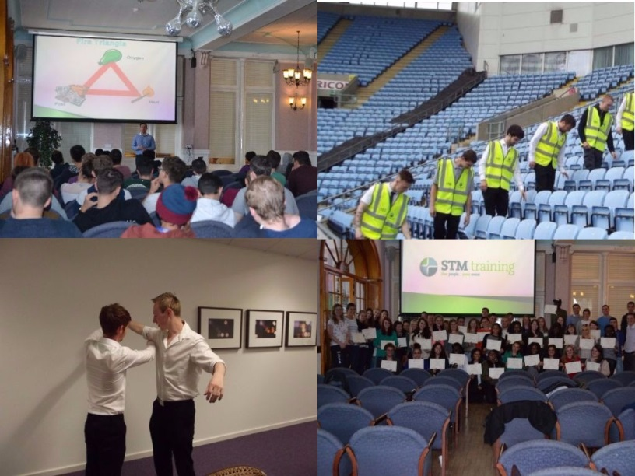

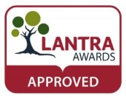

**NVQ Level 2 Spectator Safety Stewards. Our business is completely scalable to your needs; we can supply 10’s or 100’s of stewards.**

**We provide all course candidates with their certificates upon successful completion of their qualification. We retain a copy of this on file for reference.**

**We train all stewards and security operatives in body and baggage search techniques. Our stewards can therefore step in to fulfil duties if required.**

**We design and implement temporary Traffic Management solutions to manage your outer road network. All TM Operatives are Lantra T1 + T2 qualified.**



A partner that has a track record of hitting your steward requirement numbers 97% of the time – and in those 3% we could not – we made sure to warn in advance of match-day

All Stewards supplied are trained to the SGSA-advised **NVQ Level 2 Spectator Safety** qualification – trained by qualified trainer via classroom, assessed on match-days.

All our operatives at your venue has a **“paper-trail” of necessary right-to-work, vetting and training records** that can be provided either same/next working day on request or in advance.

**No more “ghosting” of staff** – we are a partner that is open/honest about numbers supplied – happy to work on a collaborative verification process that you can trust.

Your venue’s safe operation is not put at risk by failure to deliver sufficient manpower – safety certificate authorising full attendances is protected.

Your workforce is 100% compliant to industry standards and well trained to meet the customer and safety needs of your spectators.

You have a legally compliant workforce that is recruited through counter-terror resilient channels. Helping you pass external audits with flying colours.

Outside your venue, we are fierce competitors, inside your venue we are one team – our attitude enables you to mitigate your risk by tapping in to more than one contractor’s resources to fulfil your venue’s needs.

A contractor that is accustomed to working alongside other contractors in supporting your venue’s requirements. We have built great working relationships with our competitors at the venues we jointly supply.

You are billed for operatives that were actually present at your venue – eliminating wasteful spending and driving greater accountability.

In 2016/2017 season we achieved 97% success rate

**Our Features**

**Your Benefits**

NVQ Lvl 2 Spectator Safety Trained

Paper Trail records of every operative

No more “ghosting” of staff

“One Team” Mentality