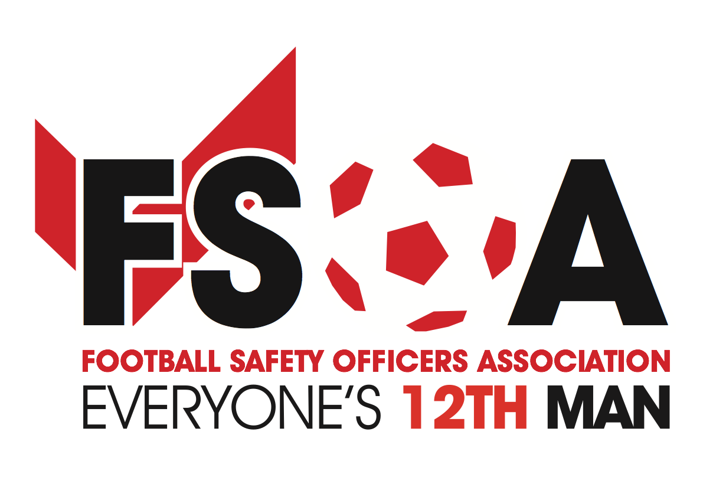

**FSOA AGM Spring Conference & Exhibition**

NOW COMPLETELY SOLD OUT

*Early bookings now being taken for our anniversary October event*

The FSOA’S Spring AGM Conference & Exhibition on March 28th and 29th has now completely sold out for exhibitors and members, with only a handful of places remaining for paying day delegates.

Early bookings are now being taken for our Autumn event, which will take place on October 3rd and 4th at a venue to be confirmed.

The event will mark the milestone 25th anniversary of the FSOA and will include celebrations to honour the organisation’s invaluable work to improve safety procedures at stadiums across the country.

Final preparations are now being made for the sold-out Spring event, which will give organisations in the events industry the chance to showcase their products and services whilst networking with experts.

The event will take place at The Stratford Manor Hotel, in Stratford-upon-Avon. A packed programme of talks and activities has been lined up, focusing on a range of relevant issues such as national terrorism threats, real-life insights into football stadium safety and Q&As with high-profile speakers.

An evening dinner will take place following the conference, which will feature football legend Dean Saunders as the special guest speaker, reliving tales about his achievements as a footballer. The evening celebrations will be compered by Andy Ashworth and will also feature comedian Ian Irving.

Award-winning events and venue security specialist, Showsec, is once again the main sponsor of the event whilst leading surveillance company, Dallmeier, is continuing its support of the FSOA as associate sponsor.

John Newsham, FSOA Business Development and Membership Manager, said: “Our Conference and Exhibition events are always a huge success and provide organisations with a platform to network with industry experts, share knowledge and best practice, whilst also showcasing their own services and products.

“We are delighted that our Spring event has completely sold out for exhibitors and members, with only a few places remaining for paying day delegates. We are now busy with the final preparations to ensure the event is another great success.

“We have started taking early bookings for our next event, which will be held in October and mark 25 years of the FSOA. It will be a prestigious event celebrating the vital work of the FSOA in continuing to improve all aspects of stadium safety. Several corporate partners have already secured their place so early bookings are recommended for anyone who wants to be part of it.”

For more information about booking exhibition space at the October AGM Conference & Exhibition, email [info@fsoa.org.uk](mailto:info@fsoa.org.uk)

