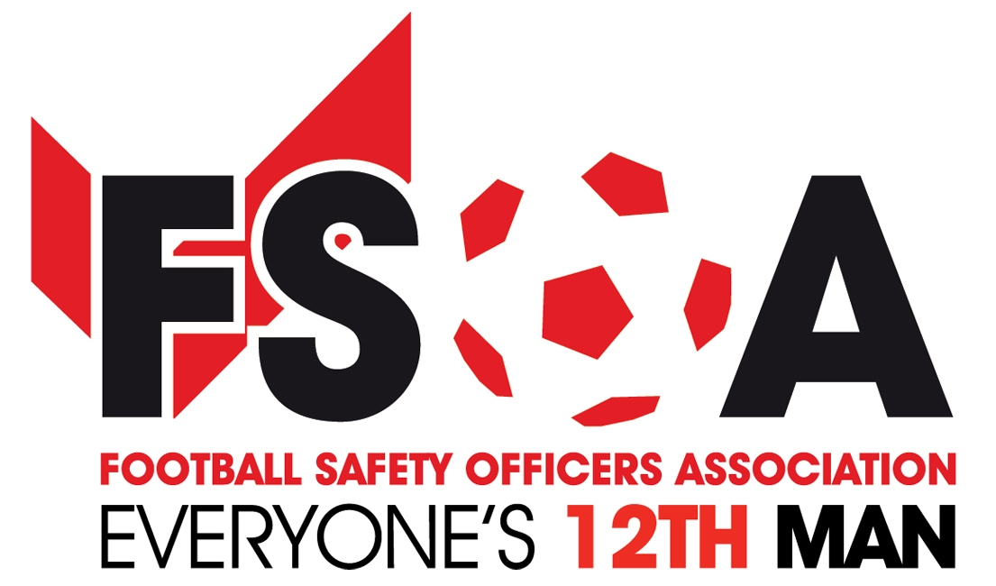

# FSOA Autumn Conference speakers

We are delighted to announce details of this year’s Autumn Conference speakers, at The Stratford Manor Hotel, in Stratford-upon-Avon, on October 12.

The conference agenda will be issued nearer to the conference date, but we are delighted to announce the following speakers at this year’s autumn conference.

**David Conn Speaking on the Hillsborough Verdict** 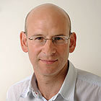

David Conn is a multi-award-winning journalist for the Guardian newspaper, widely respected as one of the foremost investigative writers on football. He has been awarded the UK's sports news reporter of the year a record three times, in 2004, 2009 and 2013, and sports journalist of the year in the British Journalism Awards in 2013. He has three times been named football writer of the year by the Football Supporters Federation.

He is the author of three acclaimed books critically investigating and chronicling English football's commercial transformation since the formation of the Premier League in 1992: *The Football Business* (1997), *The Beautiful Game?: Searching For The Soul Of Football (2004)*, and *Richer Than God: Manchester City, Modern Football And Growing Up (2012).*

His 2009 article for the Guardian detailing the bereaved Hillsborough families' continuing campaign for justice prompted the then Labour ministers Andy Burnham and Maria Eagle to press for all official documents relating to the disaster to be released. David has more recently covered the two-year long new inquests into the disaster for the Guardian and has been widely acclaimed for his in-depth coverage and analysis following the recent conclusion to the proceedings.

<https://www.theguardian.com/football/2016/apr/26/hillsborough-disaster-deadly-mistakes-and-lies-that-lasted-decades>

<https://www.theguardian.com/uk-news/video/2016/apr/26/hillsborough-inquiry-anatomy-of-a-disaster-video>

<http://www.theguardian.com/uk-news/ng-interactive/2016/apr/06/hillsborough-victims-the-96-people-whose-lives-were-cut-short>

**Phil Rainford (Manchester United) The Evacuation at Old Trafford**

**Martin Knight (BSKYB)**  **"A stadiums duty of care to Broadcasters - discuss"(Non-participation is not an option)**

**Ronnie Hawthorne & John Paul Taylor (Celtic FC) Introduction to Rail Seating**

**Claire Worley (CTU) Up-date on counter terrorism.**

Claire Has become a regular speaker on counter terrorism at the FSOA conferences and we are delighted once again to invite Claire to speak at the conference and up-date the members.

**Jill McCraken. PNN Police Operation Gothic.** Will link in with Claire Worley on their presentation.

**Anna Jonnson (Kick it Out)** 

**Karen-Eyre-White.**  **(SGSA) UP-DATE ON THE 6TH Edition of the Green Guide** Karen says she is delighted to have joined the Sports Grounds Safety Authority as Chief Executive and the FSOA are very pleased once again to invite Karen to speak at the October conference.

**Ken Scott (SGSA) 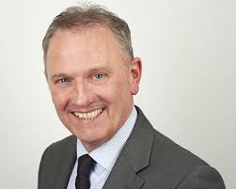 Ken has recently been appointed chief Inspector at the SGSA**

We will also have the very popular question and answer session hosted by the vice chair of the FSOA, Mark Miles.

Also a chance to visit some of the FSOA corporate members exhibiting their products in the exhibition hall.

Don’t forget to book your place at this event, **FREE** day delegate places for all paid up members in division 1 and below. (subject to booking on or before 1st September)

Accommodation available through the FSOA office with evening dinner on the 12th which includes an audience with **Sir Geoff Hurst, humourist Josh Daniels and hosted by Andy Ashworth.**

Accommodation also available through the FSOA office for the 11th October for the very popular

**“Curry Quiz Night” Book your place now at** [**info@fsoa.org.uk**](mailto:info@fsoa.org.uk)

**Blackburn Rovers Enterprise Centre, Suite 5,**

**BRFC, Ewood Park, Blackburn, BB2 4JF**

**Reception: 0844 2252350 Office: 01254 841771 Fax: 01254 693285 Email: info@fsoa.org.uk**

**Registered in England 4959698 VAT Number 824 5429 27**

|  |
| --- |
|  |