 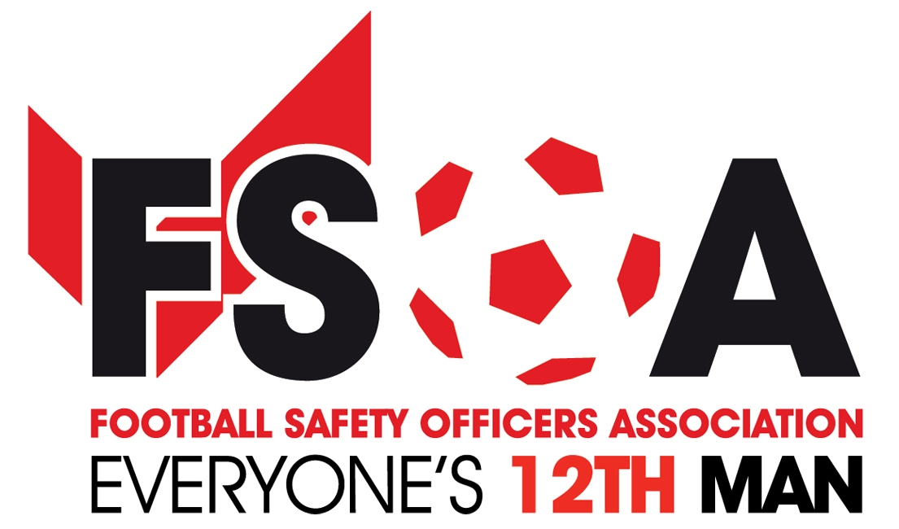

**FSOA Autumn Conference & Exhibition 11th & 12th October 2016**

# Venue: The Stratford Manor Hotel, Stratford-Upon-Avon,

# Warwick Rd CV37 0PY

**MEMBERS BOOKING FORM**

**(Prices Held yet again)**

**Member:_____________________________Club___________________**

**Member:_____________________________**

**Member:_____________________________**

**Member:_____________________________**

**E-mail Address_____________________TEL___________**

|  |  |  |  |
| --- | --- | --- | --- |
| **One or two Full Day Event with one or Two Night’s Accommodation** | **Tuesday 11th** | **Wednesday 12th** | **Yes**  **No** |
|  |  | Conference |  |
|  | Themed quiz/ Curry night. | Exhibition |  |
| **Cost £285.00 per person inclusive of VAT for two nights or £165.00 inclusive of vat for one night.** | Overnight Accommodation | Dinner & Overnight  Accommodation  Tuesday Night only  Wednesday night only  Tuesday & Wednesday nights. | £  £165.00  £165.00  £285.00 |

|  |  |  |  |
| --- | --- | --- | --- |
| **Day Delegate Option** | **Tuesday 11th** | **Wednesday 12th** | **Yes**  **No** |
|  |  | Conference/ Exhibition |  |
| **Cost £60 per person inclusive of vat** | Paid in advance  Y/N | Pay on arrival  Y/N | Paid £  Date |
| **Free day delegate places.\*\*** |  |  |  |

** Conditions apply, 1st Div and below, free Day Delegate places for full paying members.

Please e-mail booking requests to: [info@fsoa.org.uk](mailto:info@fsoa.org.uk)

If you wish to pay without an invoice, please make cheques payable to

**FOOTBALL SAFETY OFFICERS ASSOCIATION** and send to:

FSOA, Suite 5, Blackburn Rovers Enterprise Centre, Ewood Park, Blackburn, BB2 4JF

*Please note that cancellation charges of 50% of the original booking fee will apply if cancellations are received within fourteen ( 14 ) days prior to the event day.Bookings will not be confirmed until FULL PAYMENT has been made .No refunds on cancellations within 48hrs of event./Invoices will be forwarded by e-mail*



**Sponsors of the Autumn Conference 2016**

**Book a table of ten (10) for your club (Y/N) Ask for details. Bring your club secretary or Chief Executive to the exhibition & conference. Don’t miss the evening dinner on the 12th. We have an audience with Sir Geoff Hurst, plus comedian Josh Daniels, hosted by Andy Ashworth.**