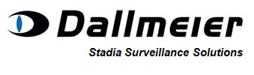 **Autumn Conference and Exhibition 12th October 2016**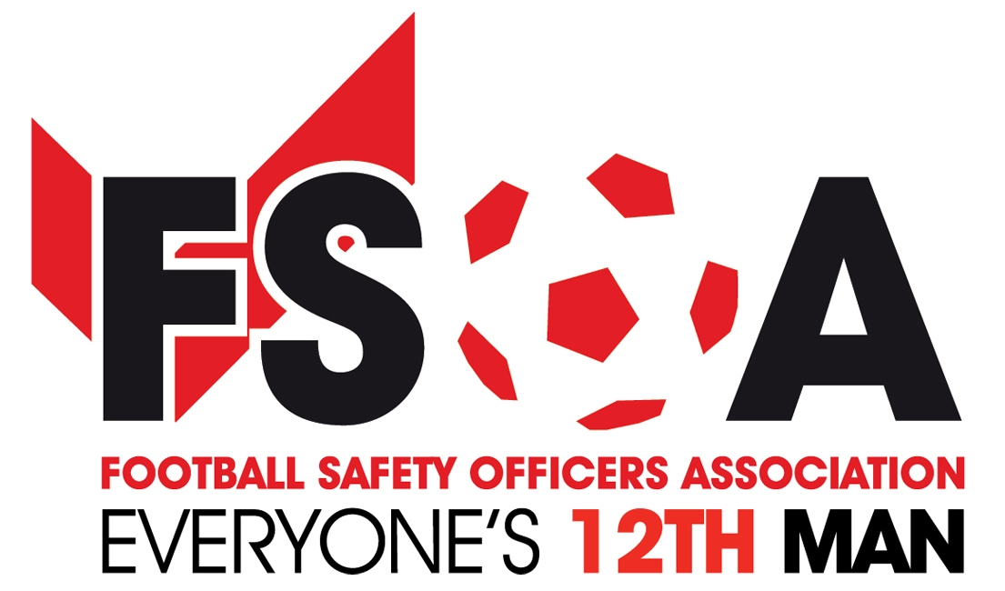

**Dallmeier continue their sponsorship of the FSOA Autumn Event.**

The FSOA are pleased to announce the continued support of Dallmeier Stadia Survaillance Solutions who are once again sponsoring the themed evening: **“Curry & Quiz Night” -** back by popular demondon Tuesday the 11th October.

This is an evening not to be missed!

Dallmeier are also sponsors of the Video Wall, Dinner Wine, Host and Guest Speaker. This will be an audience with **Sir Geoff Hurst -** 50 years on from the 1966 World Cup.

The FSOA and its members welcome the continued support from Dallmeier who will be exhibiting their products again at the exhibition on the 12th.

We would also like to remind you of the **Funded Video Surveilllance Scheme** which can be found on the Dallmeier page of the FSOA website.

Why not bring your Stadium Facilities Manager along or your Club/Company Secretary or better still your Chief Executive.

Early booking is recommended especially for the evening dinner on the 12th. Rooms will sell out quickly for this evening.

Request a booking form from info@fsoa.org.uk.

We look forward to seeing you there.

John Newsham.

Business Development and Membership Manager