Autumn Conference & Exhibition 12th October 2016 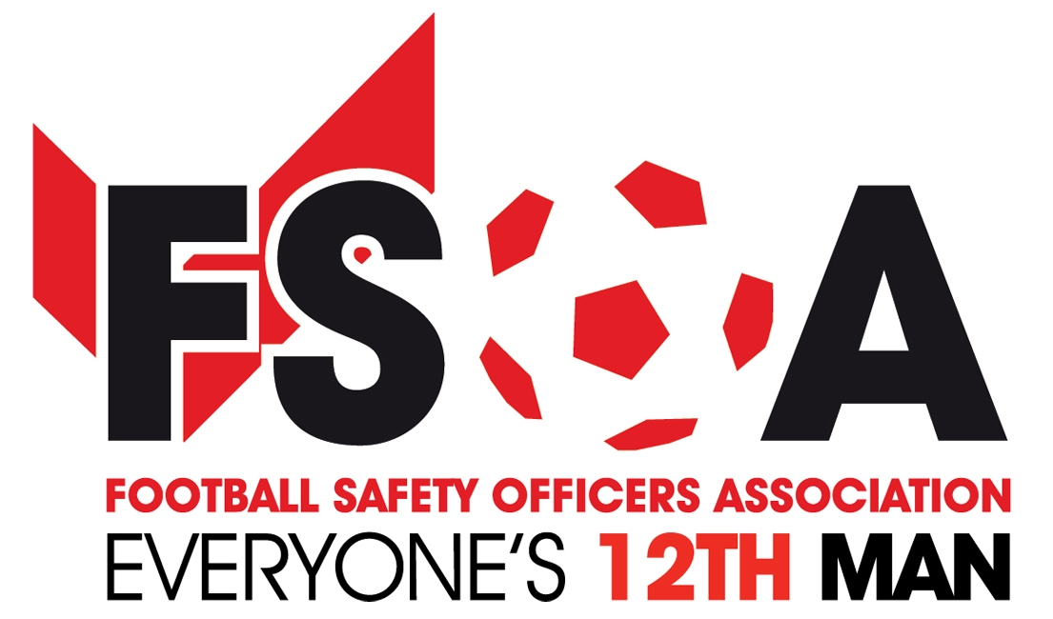 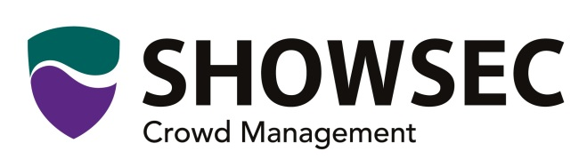

Showsec continue their sponsorship of the
FSOA Autumn Conference and Evening Dinner

The FSOA are pleased to announce the continued support of Showsec the FSOA’s, main sponsor for the Autumn Conference and evening dinner on the 12th October 2016
As part of the continuing relationship, we are extending the FSOA and Showsec initiative to assist member clubs in league 0ne and below that meet the criteria for free assistance with stewarding of F.A Cup fixtures, is to continue for the season, 2016/17.
Any member club in league one and below can apply for free F.A. Cup assistance with stewarding. Applications should be made to the FSOA office via e-mail and on completion of the criteria form. The form can be downloaded from the FSOA website which can be found under members documents in the download section and forwarded to the office at info@fsoa.org.uk .All requests are subject to funding being available and at the discretion of the FSOA Management Board.
Don’t miss this chance to meet with the FSOA’s major sponsor at this prestigious event and also attend the evening dinner with host Andy Ashworth who will host an audience with Sir Geoff Hurst 50 years on from the 1966 world cup and also comedian Josh Daniels.
Early booking for this conference and evening dinner and accommodation is strongly recommended. Request your booking form from info@fsoa.org.uk
Business Development & Membership Manager
John Newsham

